**It is a really powerful concept**

Function overloading basically means two or more function with the same name may exist having different parameters

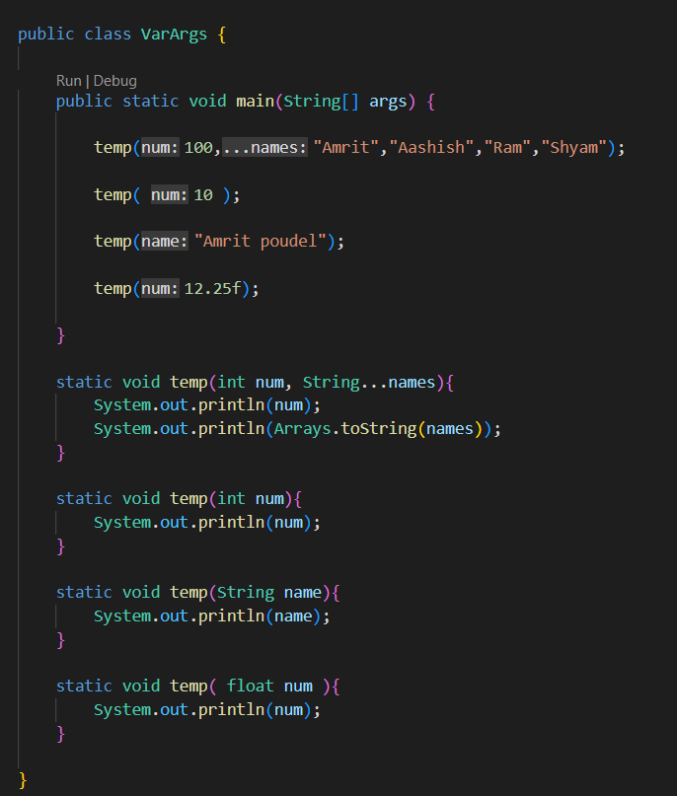

And based on the arguments passed the corresponding method is executed

**Note**

The program decides which function to execute during compilation

Function overriding is something which occurs at run time

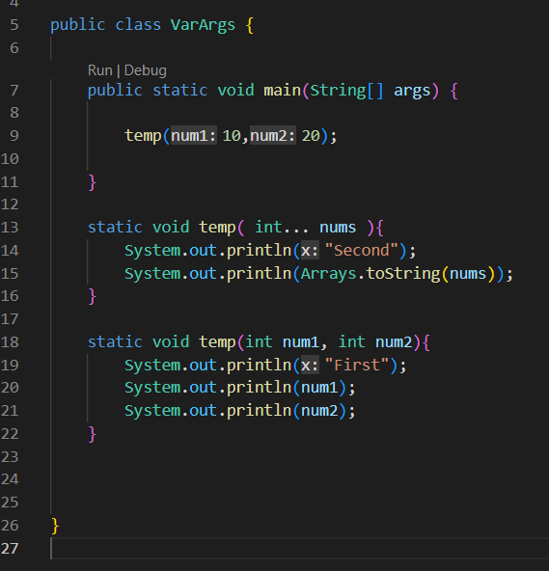

During such condition, the one without variable length argument is run first